Tutorial 4

Module Name: Login Module – Functional & Non-Functional Testing
Test Case ID: TC04
Tester Name: Vora Riya

Scenarios:
- Scenario ID: 4a
Scenario
Verify login with valid credentials
Test Steps
1. Open Demo Web Shop Login page.
2. Enter registered email.
3. Enter correct password.
4. Click Log in.
5. Observe the result.

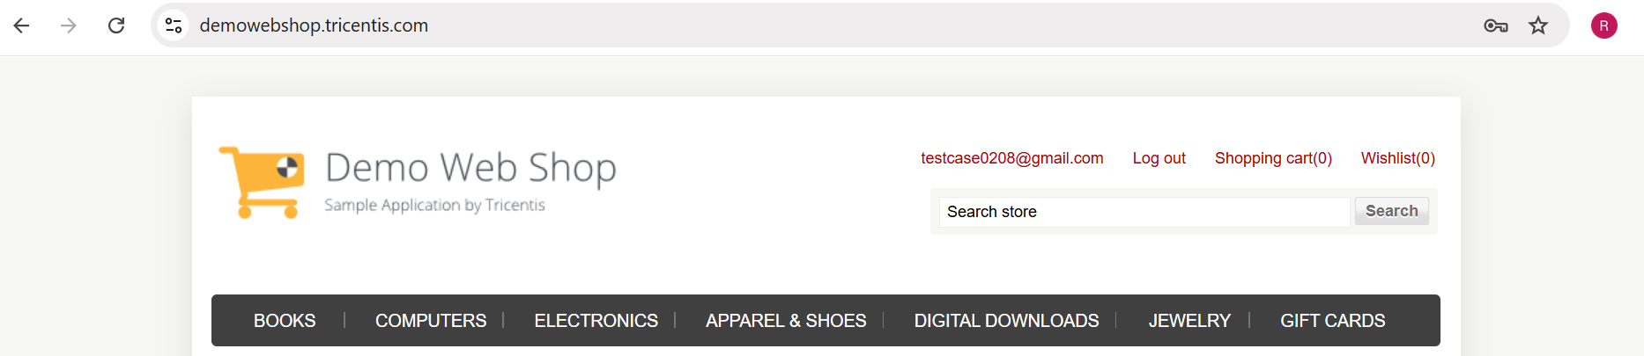

- Scenario ID: 4b
Scenario
Verify login with invalid/unregistered email
Test Steps
1. Open Login page.
2. Enter unregistered email.
3. Enter password.
4. Click Log in.
5. Observe error.

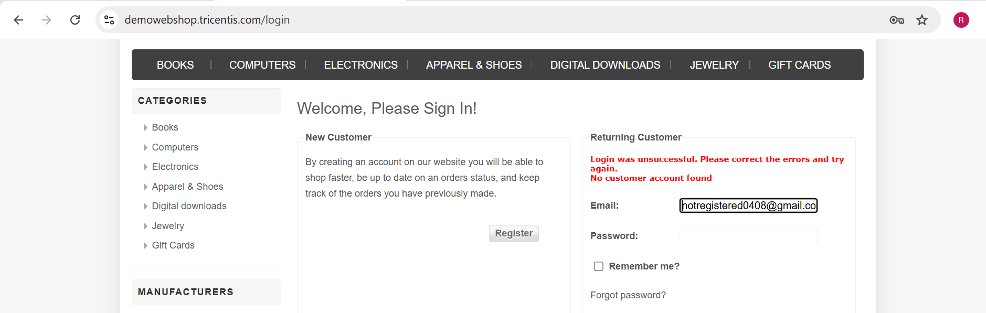

- Scenario ID: 4c
Scenario
Verify login with invalid password
Test Steps
1. Open Login page.
2. Enter registered email.
3. Enter incorrect password.
4. Click Log in.
5. Observe error.

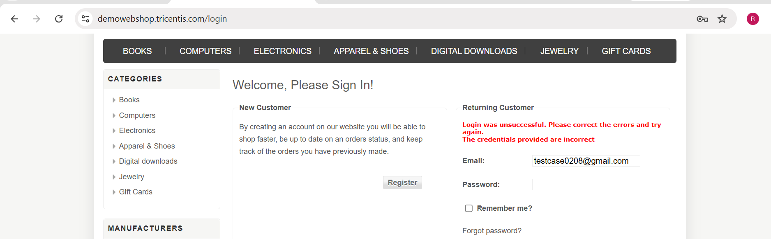

- Scenario ID: 4d
Scenario
Verify login when both email and password are invalid
Test Steps
1. Open Login page.
2. Enter unregistered email.
3. Enter wrong password.
4. Click Log in.
5. Observe result.
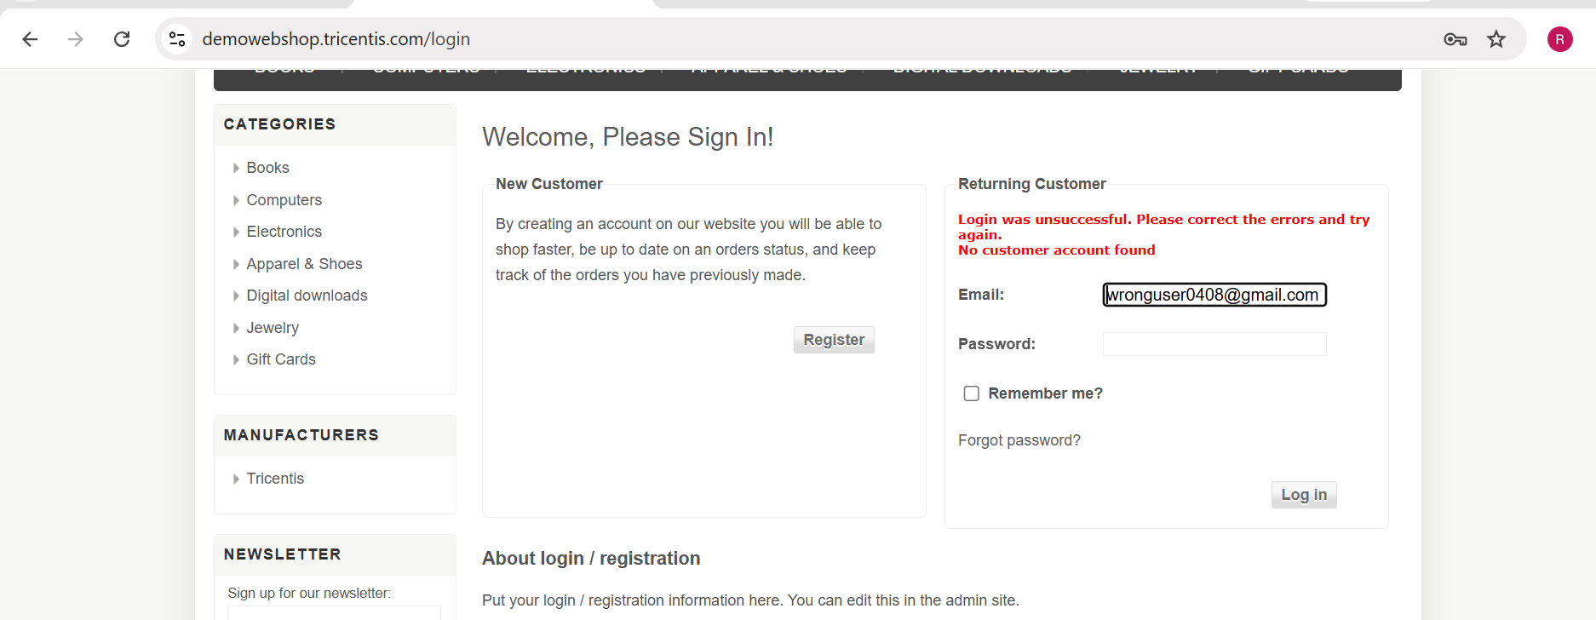

- Scenario ID: 4e
Scenario
Verify login with blank email
Test Steps
1. Open Login page.
2. Leave Email blank.
3. Enter password.
4. Click Log in.
5. Observe the result.

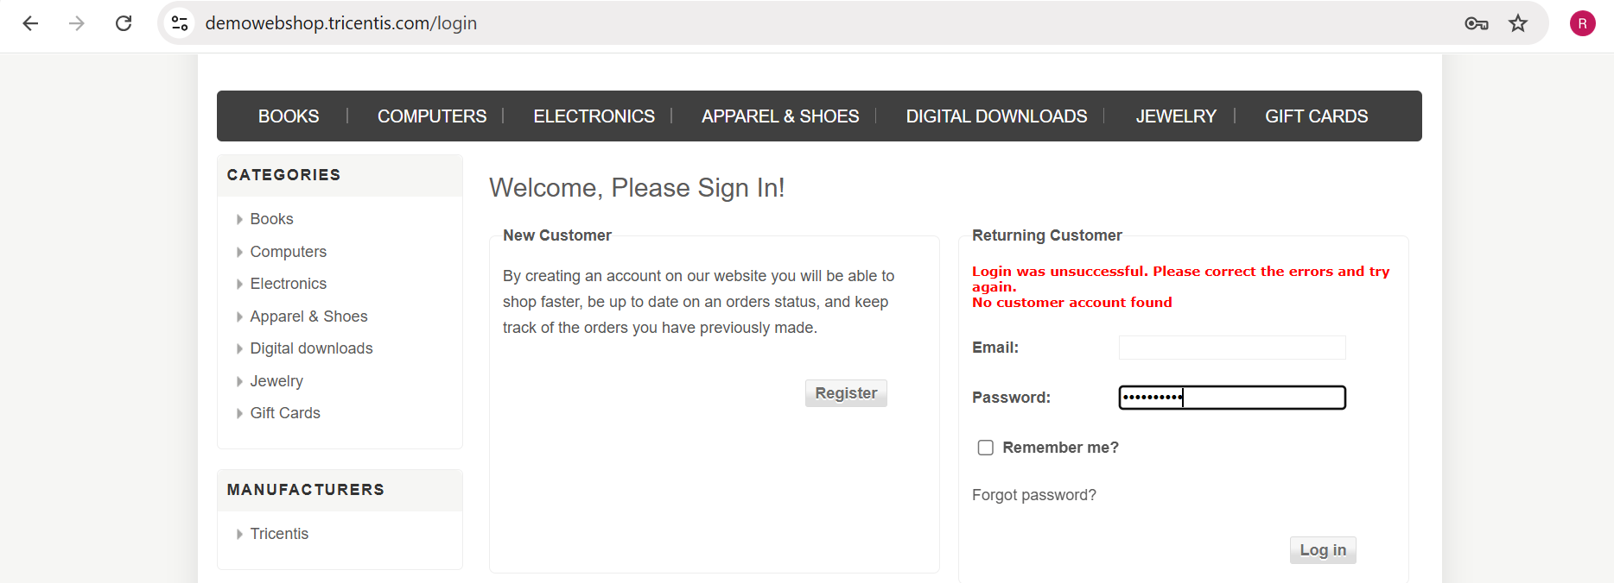

- Scenario ID: 4f
Scenario
Verify login with blank password
Test Steps
1. Open Login page.
2. Enter registered email.
3. Leave Password blank.
4. Click Log in.
5. Observe the result.

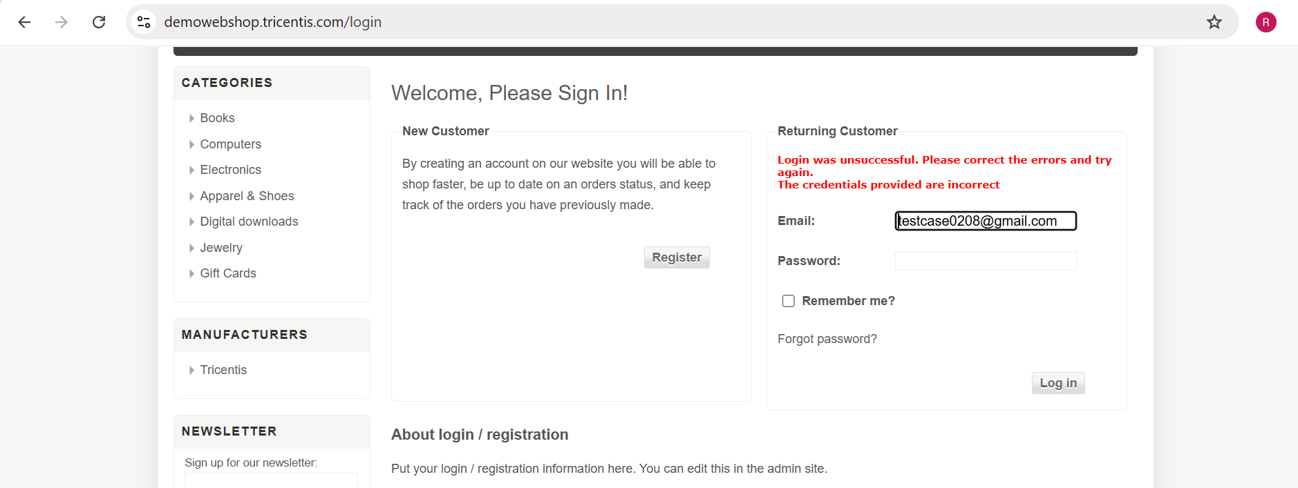

- Scenario ID: 4g
Scenario
Verify login with both email and password blank
Test Steps
1. Open Login page.
2. Leave Email blank.
3. Leave Password blank.
4. Click Log in.
5. Observe the result.

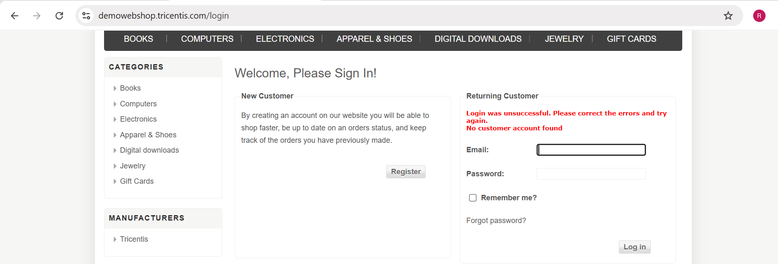

- Scenario ID: 4h
Scenario
Verify browser compatibility of Login page
Test Steps
1. Open Microsoft Edge.
2. Navigate to Demo Web Shop Login page.
3. Observe page rendering and controls.

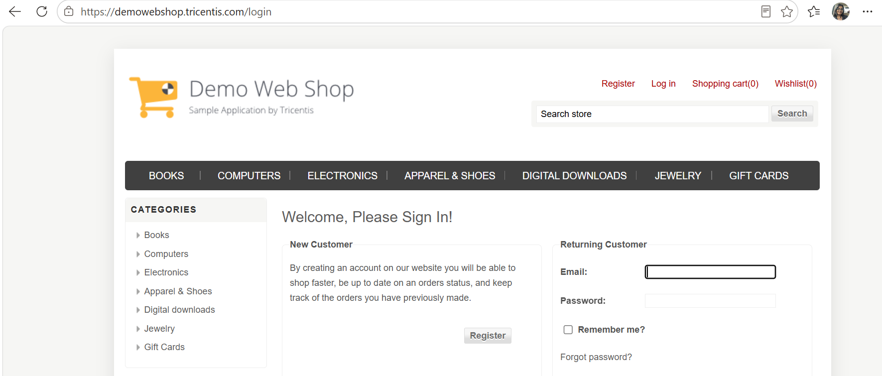

- Scenario ID: 4i
Scenario
Verify usability of Login page
Test Steps
1. Open Login page.
2. Inspect headings, field labels, buttons and account options.
3. Check whether controls are easy to understand.
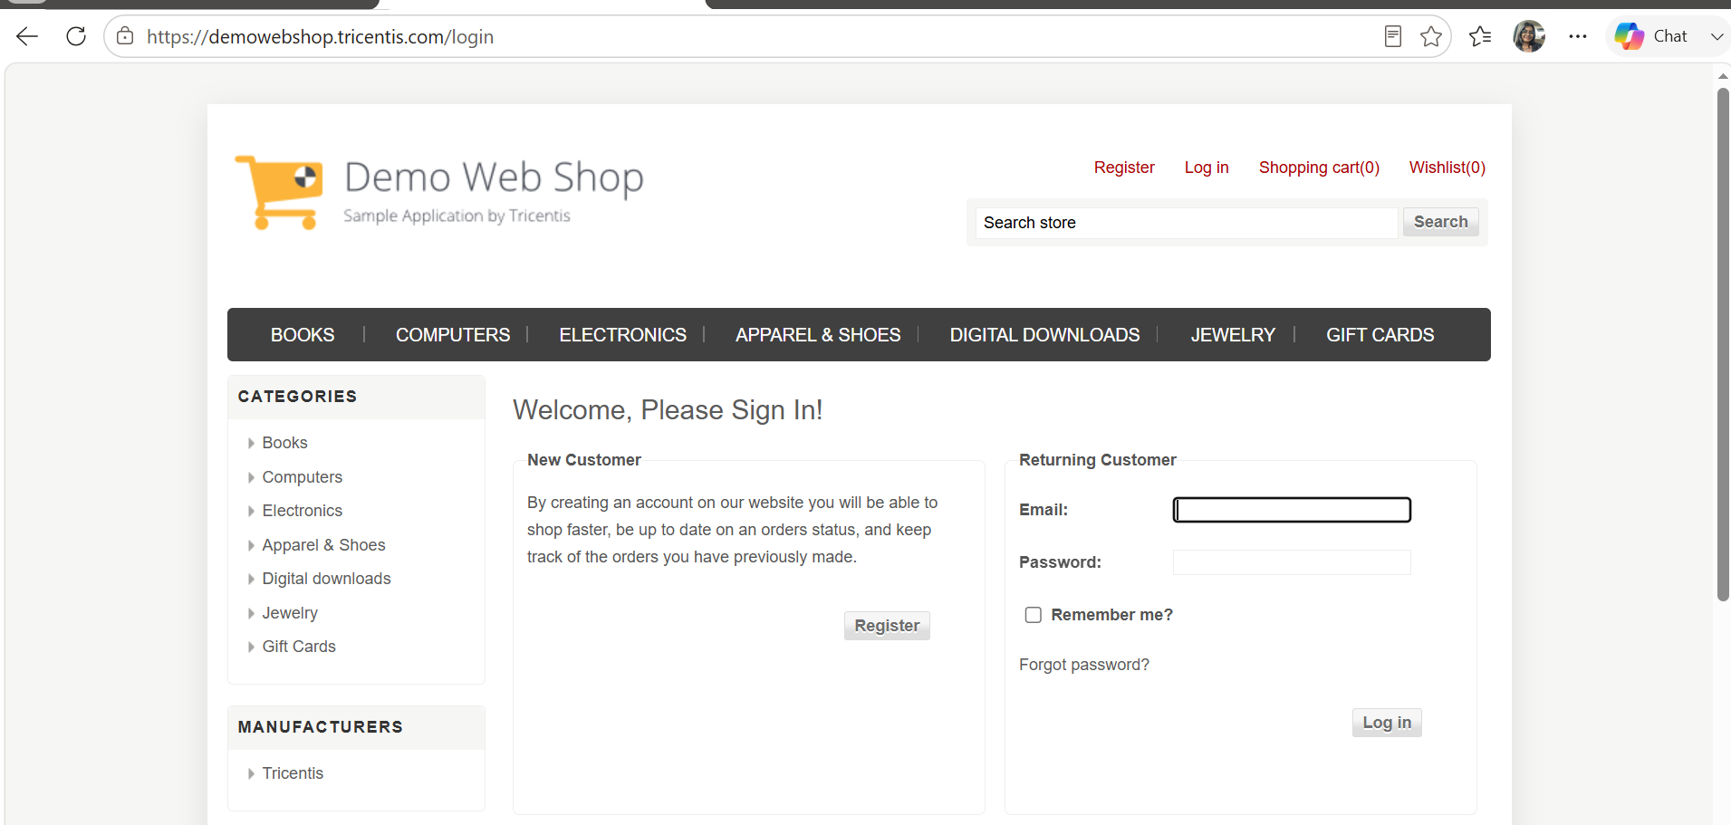
- Scenario ID: 4j
Scenario
Verify Login page layout
Test Steps
1. Open Login page.
2. Inspect alignment of sections, fields, buttons and navigation.
3. Check for overlapping or broken elements.

Test Result Summary

Total Test Case | Pass | Fail
10 | 10 | 0

